Toward an European Open Biodiversity Knowledge Management System
Making high quality biodiversity knowledge open, accessible and re-usable

FOR IMMEDIATE RELEASE
Leiden, the Netherlands - October 29th, 2012
A consortium consisting of major European biodiversity organizations, including natural history museums, botanic gardens, companies and biological societies, announce the launch of pro-iBiosphere. This EU e-Infrastructure coordination project is targeting the preparation of the European Open Biodiversity Knowledge Management System.
During its two-year duration, pro-iBiosphere aims to prepare (= pro), through a coordination action, the ground for an integrative system (= sphere) for intelligent (= i) management of biodiversity (= bio) knowledge. Once it becomes operational, the European Open Biodiversity Knowledge Management System will play a major role in facilitating the synthesis of core biodiversity data. It will create an authoritative framework including discovery of new species, naming of specimens and species, identification tools, descriptions, and various other basic types of information. It will also facilitate the acquisition of high quality biodiversity data from various sources, including legacy data; the curation of the data; and at the same time it will optimize the delivery of those data to users.
Press Release
Biodiversity science encompasses multiple disciplines (e.g., taxonomy, ecology, genomics, etc.) each with its own language, tools and data, to study the diversity of life in our planet and the environments it lives in. Motivated by the urgent modernization of the production and accessibility of these high quality biodiversity data, information and knowledge, the goal of pro-iBiosphere is to:
- Allow to streamline core biodiversity data mobilization,
- Facilitate semantic interoperability with services in general,
- Provide strategies to sustain useful workflows and pipelines,
- Help to make core biodiversity data and information accessible to various stakeholders,
- Define the optimal legal framework and policies for the system to work.
Workflows are highly dependent on data availability. The task of matching suitable data to workflows can be made easier through the use of consistent data governance and semantic presentation approaches across the many potential sources of biodiversity data at the international level.
«There is no doubt that we are entering an era where we will be overwhelmed by data. Information sciences are surely the key to being successful in this situation. The pro-iBiosphere activities represent an exciting and potentially important advance in the provision of key infrastructure to support the European biodiversity research community», says Dr. Vincent S. Smith, coordinator of the EU FP7 ViBRANT project at the Natural History Museum London (NHM).
pro-iBiosphere is an integrated project under the 7th Framework Programme (grant agreement no. 312848), to strengthen the development of a consistent and dynamic European policy for research infrastructures including the data produced by this infrastructure. The €1.3M coordination and support action brings together a complementary blend of partners representing scientific and technological expertise in the domains of biodiversity science and informatics. Participants in the project include: NBGB (Belgium), PENSOFT (Bulgaria), SIGMA (France), FUB-BGBM (Germany), MFN (Germany), Naturalis (the Netherlands), Plazi (Switzerland) and RBGK (UK). The project is supported by a distinguished scientific advisory board comprised of experts in the field of publishing, e-taxonomy and global infrastructures.
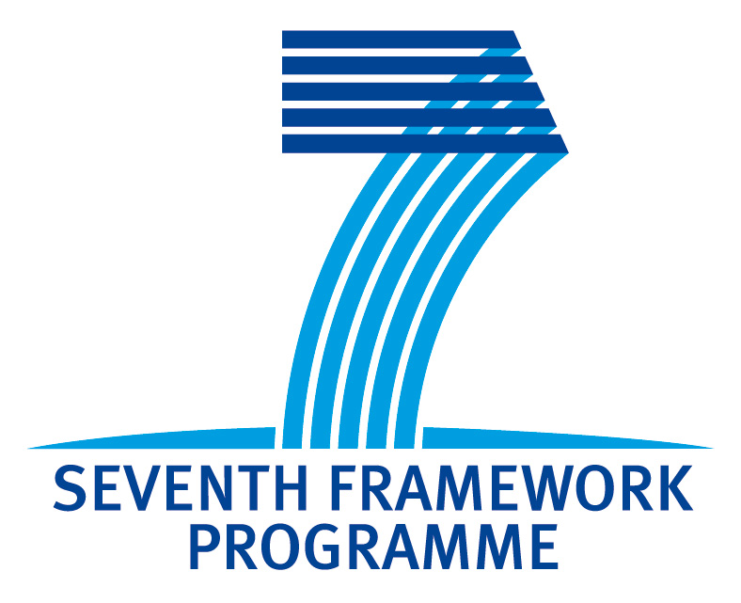 | For more information please contact:  Dr. Soraya Sierra  Project leader EU FP7 pro-iBiosphere project  soraya.sierra@naturalis.nl  www.pro-iBiosphere.eu  http://wiki.pro-ibiosphere.eu

