Recommendations for removing copyright hurdles to scientific research
FOR IMMEDIATE RELEASE
September 2nd, 2013

The EU e-Infrastructure coordination project “pro-iBiosphere”, targeting the preparation of a European Open Biodiversity Knowledge Management System, makes six recommendations for removing copyright hurdles to scientific research.

The EU e-infrastructure coordination pro-iBiosphere project is preparing the ground for the pursuit of biological research in the digital age. In its “Draft policy for Open Access to data and information” scientists and lawyers recommend that hurdles posed by copyright and database protection should be removed by establishing exceptions for research in a new binding, Europe-wide regulation. This report opens a consultation process that will last until December 2013. Input is welcomed on pro-iBiosphere’s Google+ , LinkedIn or Facebook.

At present, national provisions on copyright and database protection regarding exceptions and limitations for research purposes differ both in detail and substance. Scientists within the EU working with copyright protected works or with protected databases have to be aware that regulations may vary considerably from country to country. This can be a major stumbling block to international collaboration in science.

The document addresses legal issues that hamper an integrative system for managing biodiversity knowledge in Europe. It describes the importance for scientists to have access to documents and data in order to synthesize disparate information and to facilitate data mining (or similar research techniques). It explores some aspects of copyright and database protection that influence access to and re-use of biodiversity data and information and refers to exceptions and limitations of copyright or database protection provided for within the relevant EU Directives.

The scientists also suggest that publicly funded institutions should refrain from claiming intellectual property rights for biodiversity data and information published or made accessible by them. Re-use of biodiversity data and information for research purposes should be allowed without any form of authorization. The only claims that publicly funded institutions should make are to ensure users fully acknowledge the sources of information that they rely on.

The report concludes that the legal situation within the EU is unsatisfactory and, hence, the creation of a much-needed integrative system for biodiversity knowledge will be hampered by copyright or by database protection. The scientific community recommends that these hurdles should be removed by unifying the terms that relate to research needs in a binding, Europe-wide regulation.

The vision pro-iBiosphere is to prepare the ground for an integrating global system for the intelligent management of biodiversity knowledge (i-Biosphere). Such system will:
- Offer a robust service-oriented architecture for distributed taxon-level information
- Include a central registry of sources and services, with documentation, so that they can be discovered
- Provide open and free access to all names and taxonomic information from a single source to all persons who need biodiversity data, without legal barriers, copyright and database protection rights, nor requiring the consent of other individuals or institutions
- Facilitate the re-use of biodiversity data and information
- Be interoperable with closely related initiatives
- Be fully aware of user requirements so that it serves the community as a whole
- Have a solid long term sustainability plan to maintain the infrastructure and the services

In order to fulfil this vision, technical and semantic interoperability challenges need to be addressed; user requirements need to be known; sustainability plans need to be developed; and basic requirements like allowing open and free access to data and information and re-usability for legitimate purposes need to be in place. At present, these basic requirements are hampered by numerous factual, technical, economic, sociological and other factors as well as by putative or real legal barriers, in particular, copyright and database protection rights.

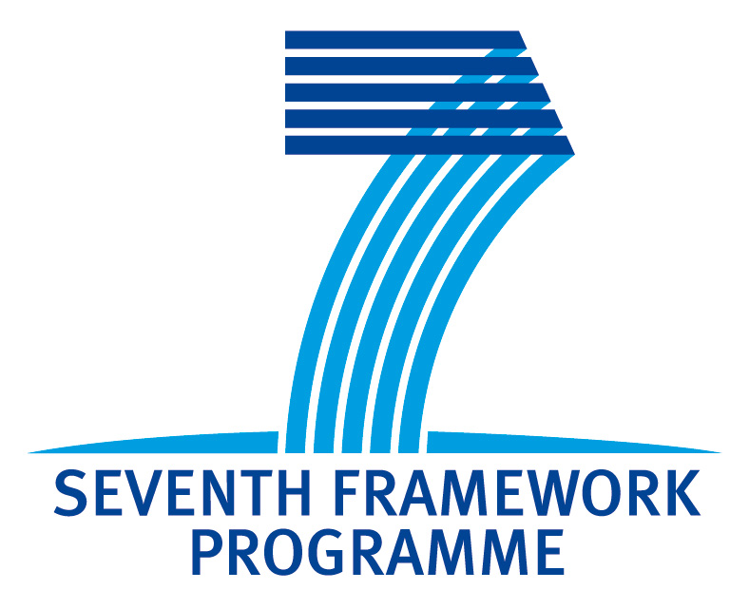 | For more information please contact:  Dr. Willi Egloff  Email: willi.egloff@advocomplex.ch  Tel: +41-79-359 3110  www.pro-iBiosphere.eu  http://wiki.pro-ibiosphere.eu

