Recommendations on how to move the naming of organisms
from paper and on to the internet
FOR IMMEDIATE RELEASE
September 2nd, 2013

The EU e-Infrastructure coordination project “pro-iBiosphere”, targeting the preparation of a European Open Biodiversity Knowledge Management System, makes ten recommendations to increase the adoption of digital workflows in the biodiversity domain.

“Well, I suppose I'd better start finding names for things…” was the first thing said by the ill-fated sperm whale (Physeter macrocephalus Linnaeus, 1758) in Douglas Adam’s Hitchhikers Guide to the Galaxy. Such is the richness of life that, unlike that whale, mankind is still naming things. Without commonly accepted names there would be no way to communicate research about life and it is the profession of taxonomists to put names on organisms and describe the different forms of life on Earth.

The EU e-Infrastructure coordination project “pro-iBiosphere”, targeting the preparation of the European Open Biodiversity Knowledge Management System, makes ten recommendations to increase the adoption of digital workflows in the biodiversity domain. The recommendations include a “focus on usability and interoperability of software, not just functionality; fostering openness with research data”; and aim at giving further stimuli to the engagement of taxonomists with digital technology. The complete list is available in the report “The use of e-tools among producers of taxonomic knowledge”. The document is based on a workshop and training organised by the project with 100 participants, a questionnaire answered by 220 persons including taxonomists and related professionals, literature review and conversations with taxonomists.

One of the attendees at the pro-iBiosphere workshops said “pro-iBiosphere is helping to close the gap between technology and taxonomists”. Thibaut DeMeulemeester, Postdoctoral researcher (Naturalis Biodiversity Center, Leiden, the Netherlands).

Taxonomy has traditionally been a paper-based occupation and due to the rules on naming priority it relies heavily on the vast corpus of literature that has accumulated since the works of Carl Linnaeus. Yet, other scientists, conservationists and resource managers are crying out for a more transparent, stable, available and linked system of names. This can only be achieved digitally, openly and on the internet.

The need for a digital system of taxonomy is higher than ever. Modern metagenomic methods have been developed that can extract DNA sequence from ‘soup’ containing hundreds of species, many of which that cannot be linked to known species and some of which may in fact be new species to science. This is an exciting new technique with the potential to teach us much about microbial ecology, evolution and diversity. Yet it presents a challenge to taxonomy. The potential for generating thousands of DNA sequence from hitherto unrecognized species means that our ability to connect the genetic and biological data with their names will be severely tested. Only a digital online system of taxonomy can hope to keep up with these exciting developments.

pro-iBiosphere aims at binding together the disparate disciplines of the life sciences and envisages the digital-taxonomist providing the names that glue it all together.

Your feedback and suggestions are welcomed on pro-iBiosphere’s Google +, LinkedIn or Facebook.

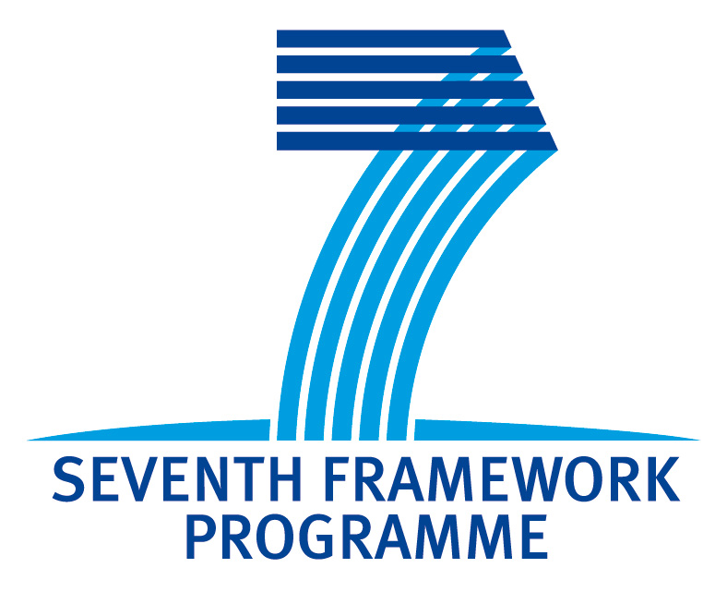 | For more information please contact:  Dr. Quentin Groom  Email: quentin.groom@br.fgov.be  www.pro-iBiosphere.eu  http://wiki.pro-ibiosphere.eu

